Student  Full Name: | Student  Number:
Subject:  ADP470S Advanced Development Practice | Test Date:  29 November 2021 | Duration:  3 Hours

Test 3
Faculty of Informatics & Design
Course:
Advanced Diploma in Information Technology
Question | Student Mark | Max. Score
1 |  | 20
2 |  | 20
3 |  | 20
4 |  | 20
5 |  | 20
 |  | 100

Subject Coordinator:
Mr T. Makhurane
Lecturers / Examiners:
Mr T. Makhurane/A Mukherjee
Moderator:
Internal:
Special instructions:
Answer ALL questions
DO NOT share your answers with others. Instances of copying will be taken very seriously.
Provide an original response to each question not a verbatim code excerpt from a source.
For the purposes of this test you are NOT allowed to use classes built into your programming language. You MUST implement all data structures using your own classes.

%

Question 1 [20]
1 | Demonstrate how the HeapSort algorithm will sort an array step by step, using the following example array.  In other words, show how the array is modified, stage by stage, until sorting is completed. {60, 90, 23, 5, 109, 12, 22, 67, 34}. Use a tree diagram similar to the one discussed in class to illustrate how the algorithm works.  - The first step will be to insert all the data from the array to a binary heap tree. For this example I will use the min heap approach where all the children nodes must be greater than the parent node. A function that creates a heap will be called and the result will look like the tree below.  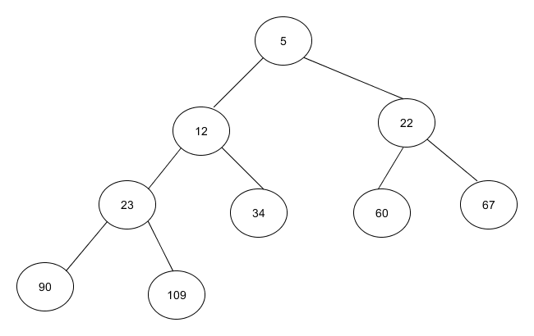  - On the second step the data will be extracted from the binary heap. By calling the method that will do that, what will happen is: The number on top of the tree (Smallest number) will be extracted from the tree and inserted on the zero index of the array, and the last child will go to the first position and the result will be as illustrated below.  5  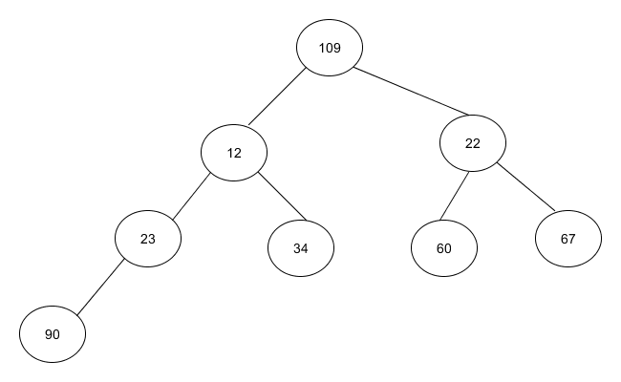  Once again the heap function will be called to create a heap, checking if all the parent nodes are smaller than its children, and if not, then sift them until a heap has been created and the result will look as shown below:  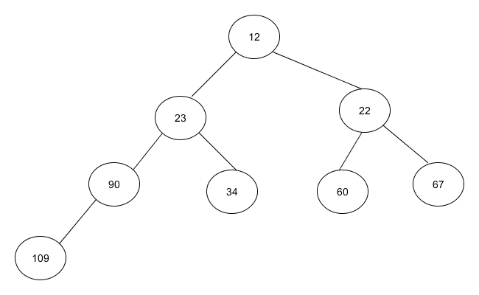  - Again data will be extracted from the heap tree to the array as done before an the array will look as follow:  5 12 | 20
The process will repeat until entire array is sorted.
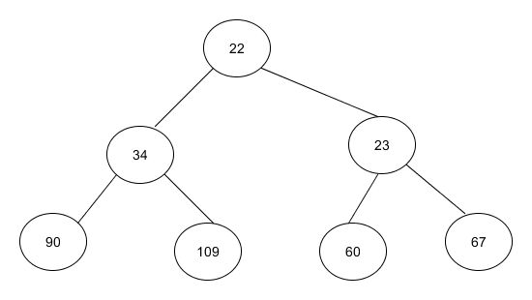
Next
5 | 12 | 22

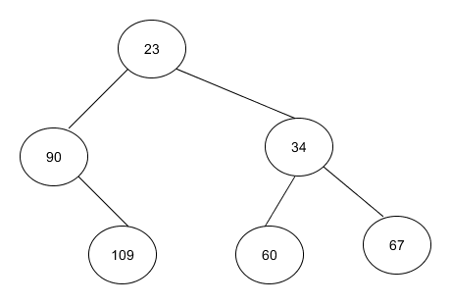
Next
5 | 12 | 22 | 23

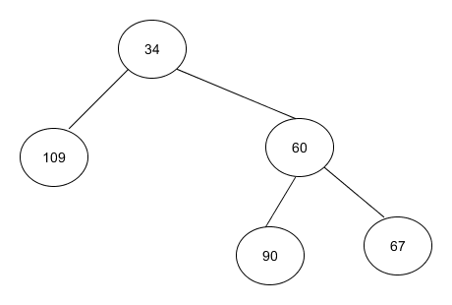
Next
5 | 12 | 22 | 23 | 34

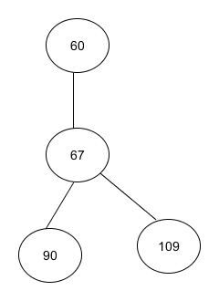
Next
5 | 12 | 22 | 23 | 34 | 60

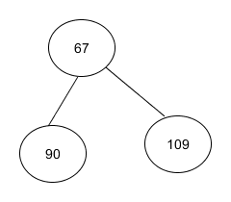
5 | 12 | 22 | 23 | 34 | 60 | 67

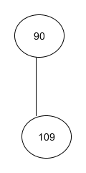
Final Sorted Array
5 | 12 | 22 | 23 | 34 | 60 | 67 | 90 | 109

Question 2
2.1 | Implement a binary search tree using a linked arrangement which includes a representation of the following operations: find, insert, delete, isEmpty, preorder, inorder, postorder. Use a pseudocode. | 16
2.2 | What is the performance of the insert operation for a Binary Search Tree? | 4
Question 3 [20]
3.1 | Implement a stack application using a linked representation. The stack should stack a class called View, where each View instance contains the following attributes: width and height.  The code should implement a running part showing how 4 View objects can be pushed onto a stack and then have their attributes printed as they are successively popped from the stack. Implement the following operations: push, pop, isEmpty, and peek. This must be implemented in an OO language (Java) (No built-in classes permitted). | 10
3.2 | Implement a queue using a circular queue data structure (circular buffer). Each element in the queue should represent a Customer object (as in a customer at a shop). The instance variables for the customer should include the following: customer_id, and fullname, This must be implemented in an OO language (Java).  The code should implement a running part in which 5 customer objects are enqueued (added to the queue) and then later dequeued, to demonstrate that the application works. The following operations should be included:  enqueue, dequeue, isEmpty, isFull. This must be implemented in an OO language (Java). | 10
Question 4 [20]
4 | Demonstrate how the QuickSort algorithm will sort an array, using the following example array. In other words, show how the array is modified stage by stage until sorting is completed. {60, 90, 23, 5, 109, 12, 22, 67, 34}. Use tables to show how the data items are exchanged as the algorithm executes. | 20
The quick sort first finds a pivot number and makes sure that all the numbers smaller that its value are stored on the left, and the values bigger than its value are stored on the right. For this example, I will use the value on the last index of the array as the pivot. Then on the subarrays apply the same logic of choosing the rightmost element and use as pivot until the entire array is sorted as shown below.

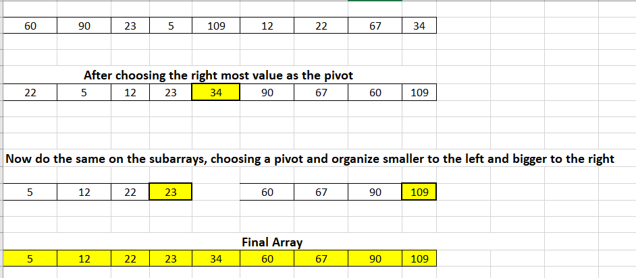

5.1  A>  B>  C> | Question 5 [20]  Given two traversals of a binary tree.  Post order traversal: 4 6 5 3 8 11 12 10 9 7 1  In order traversal: 4 5 6 3 1 8 7 9 11 10 12  Please select from the options below, which binary tree the traversals are from.  Answer A  1  3  11  9  8  4  6  5  7111111  12  10  1  3  11  8  9  4  6  5  7111111  12  10  1  3  12  9  8  4  6  5  7111111  11  10 | 5
5.2  A>  B>  C> | Given the graph below: Answer B  Please select which one is the Adjacency Matrix(A) of the Graph (Vertex 0 is the 0th row) | 4
5.3 | Given the following undirected graph:  If you are using BFS to traverse the graph starting from the node A using a queue Q which option of the following will represent the steps of Q most perfectly (Assume that the 0th column is the queue front:  A B I I I F F F E E E G G C C D H H C D A B I I I F F F E E E G G C C H H H D D  Option A Option B | 5
5.4 | Check the given connected, undirected graph below:  A  B  E  D  F  C  16  19  21  11  33  14  18  10  6  5  Use either Kruskal or Prim’s Algorithm to get the value of the minimal cost spanning tree. Select an option from below:  - The total cost of the minimum cost spanning tree is 57  - The total cost of the minimum cost spanning tree is 58  - None of the above | 6

